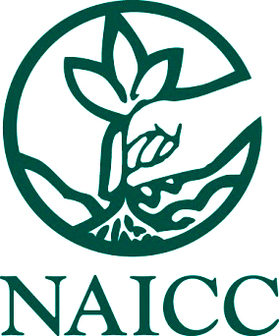

ABSTRACT SUBMISSION FORM

EMERGING and EVOLVING TECHNOLOGIES – 2022

NOTE: An abstract of 100-words or less must be submitted with each submission.

Complete one form for each submission; make additional copies as needed.

Title of Presentation: ________________________________________________________________

Contact Name _____________________________________________________________________

Contact Address ___________________________________________________________________

Contact City/State/Zip _______________________________________________________________

Contact Phone ___________________________ Contact Fax _______________________________

Contact Email _____________________________________________________________________

Presenter Name ___________________________________________________________________

Presenter’s Email (if different from above: ________________________________________________

SUBMISSION FEES
First submission from NAICC Sustaining, Voting Member or Exhibitor FREE
Additional submissions from NAICC Member or Exhibitor $500/per submission
_____ # of additional submissions after the first (no more than 5 allowed) x $500
TOTAL Enclosed $ _______

PAYMENT — required for consideration of presentation

Paid by enclosed CHECK made payable to NAICC Date ____________________

Please charge $______________ to the following credit card: (NOTE: For security reasons, feel free to call Allison Jones at 423/884-3580 to provide credit card information over the phone. Otherwise, use online form or transmit this form via email or mail.)

CC Number _________________________________ Exp. _________ Security Code ____________

Name on Card ______________________________________________________________________

Credit Card Billing Address if different from above ________________________________________

Signature __________________________________________________________________________

Phone ______________________________ Email _________________________________________

SUBMIT

Send this completed form and the abstract file via Email or USPS to the NAICC:

NAICC Email: AllisonJones@naicc.org

1700 Wood Duck Drive Phone: (423) 8884-3199

Vonore, TN 37885 Fax: (423) 264-0071

